# ` Make the website

## 1) Find the index.html for your selected portfolio and double click to open it

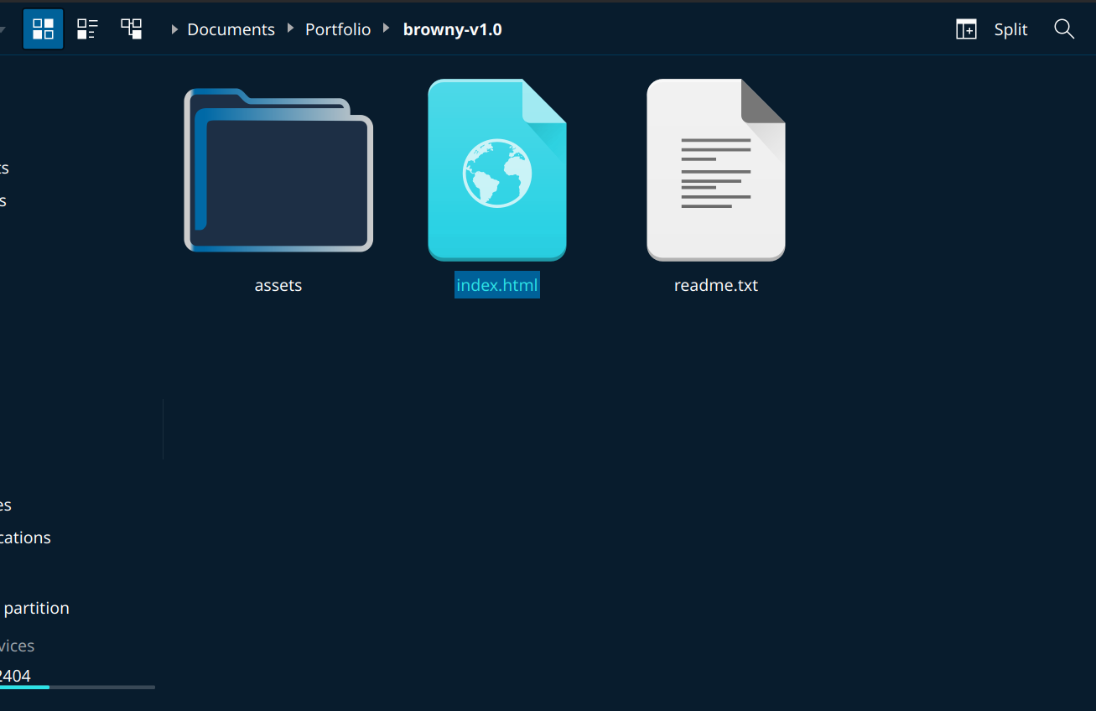

## 2) Observe it, and find parts you like and don't like

## 3) Edit index.html with your editor and add in your name and details, remove parts you don’t like

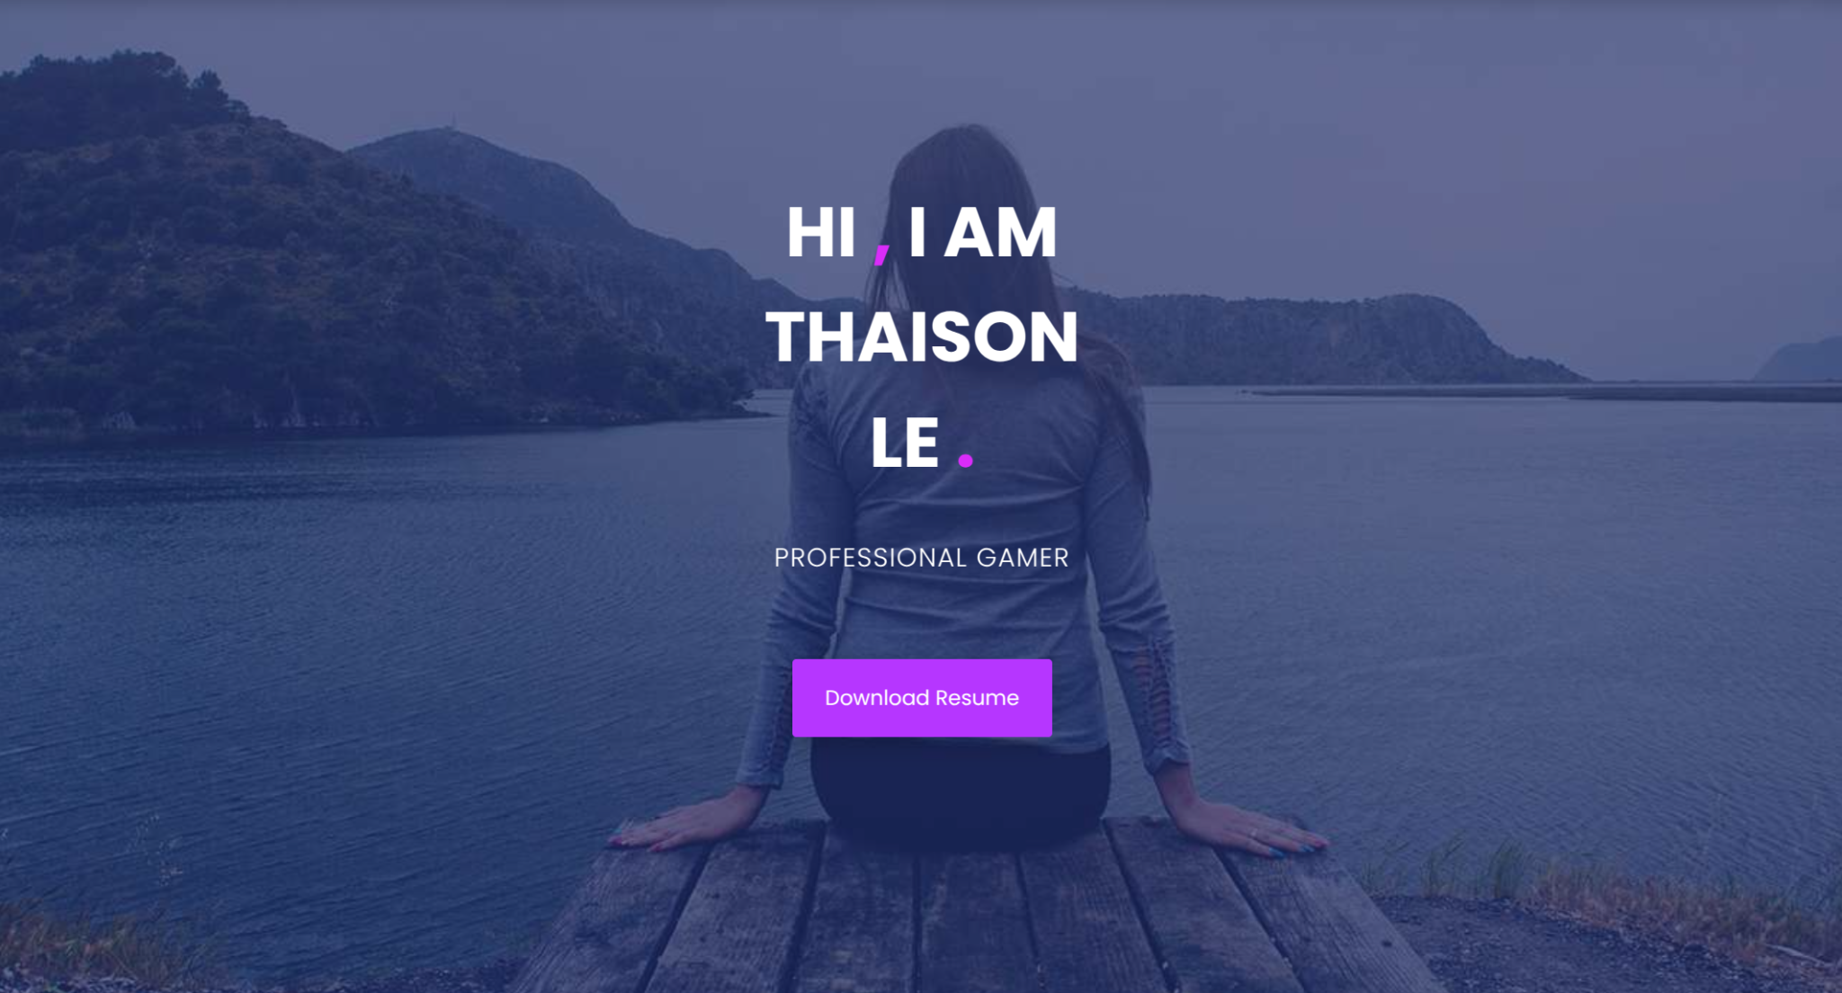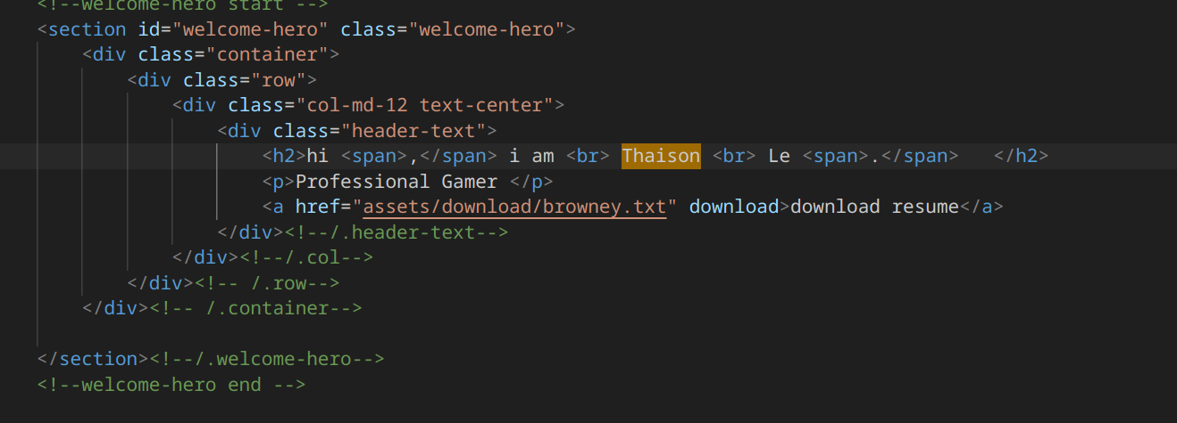

## Make the AWS Account

TBD, don’t know how CPath system will work

# Make the S3 Bucket

## Go to dashboard(Should log in to it, or else if not click on top left logo)

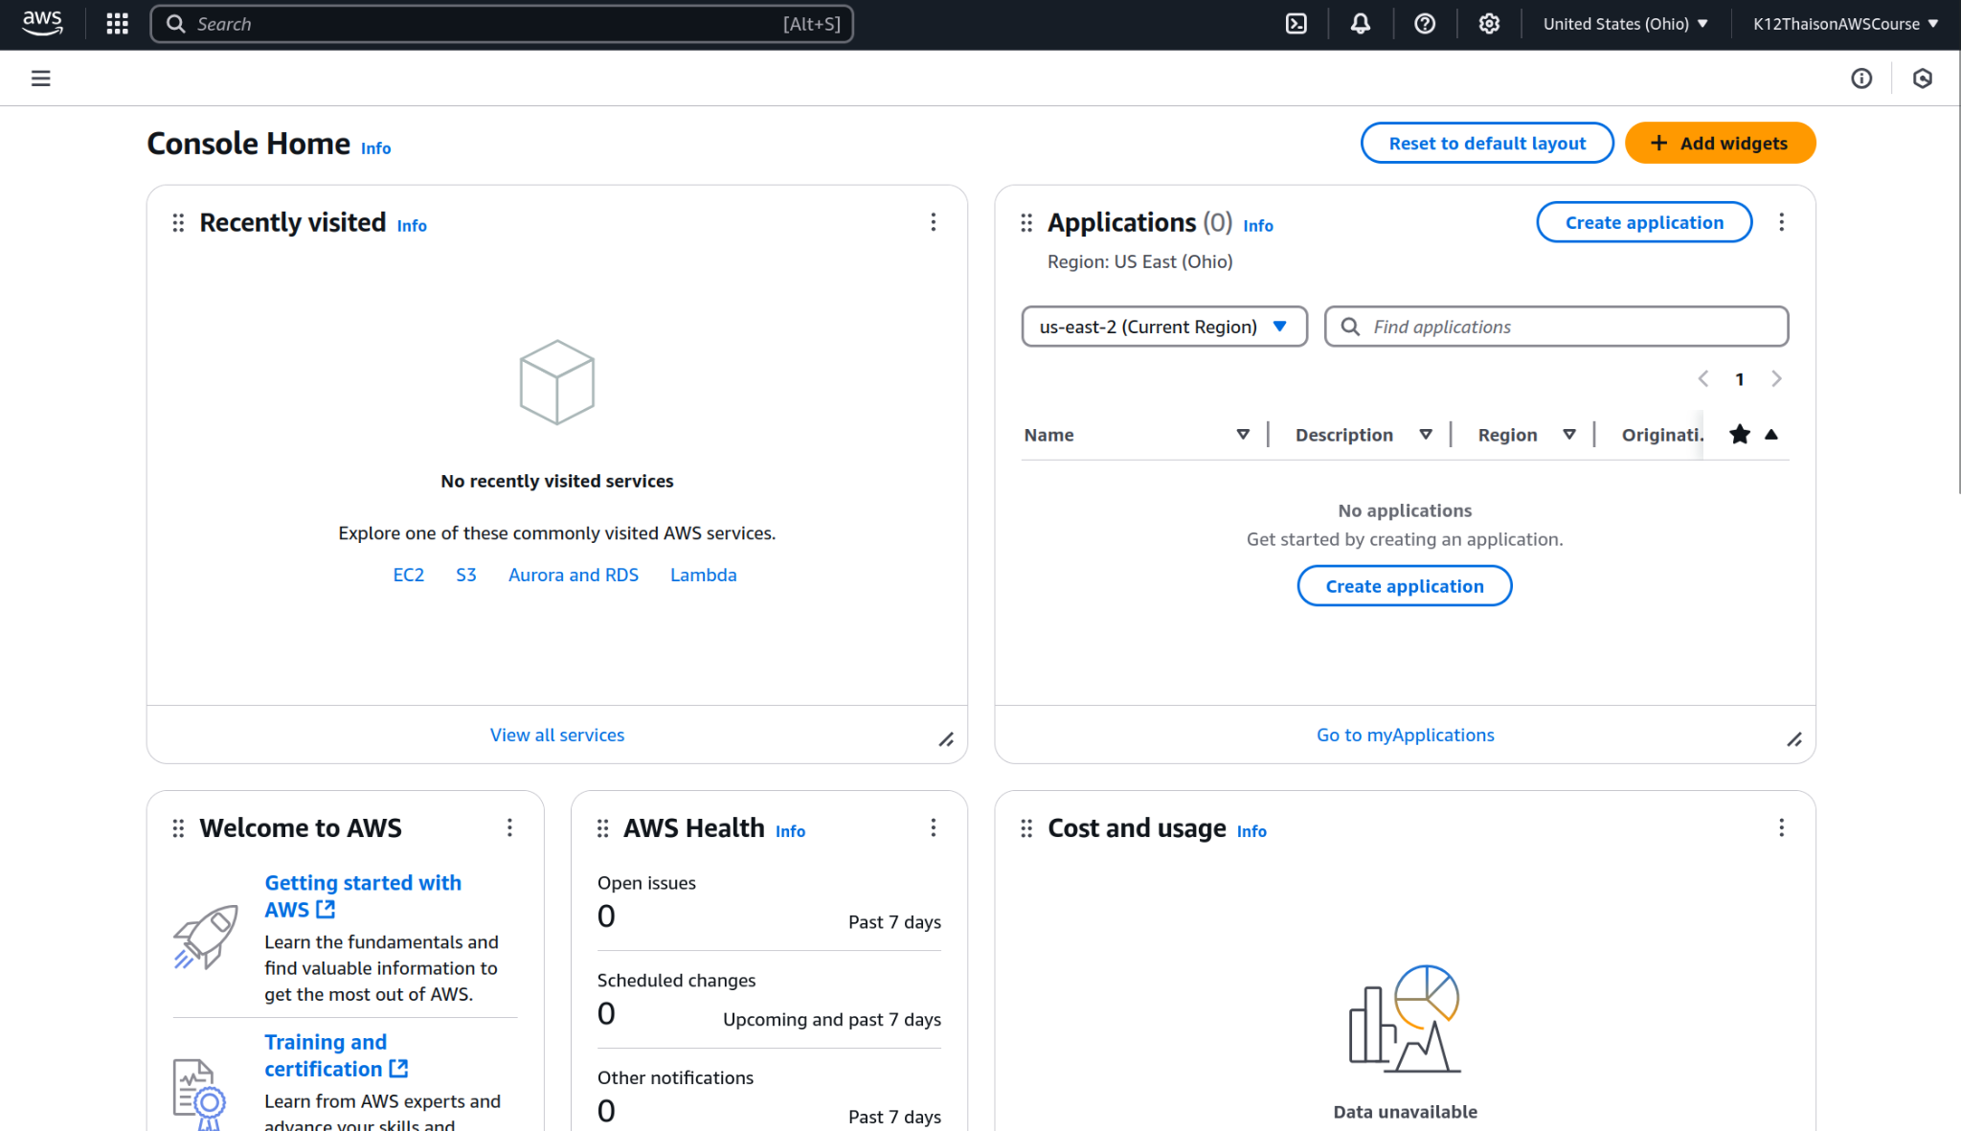

## Look up S3

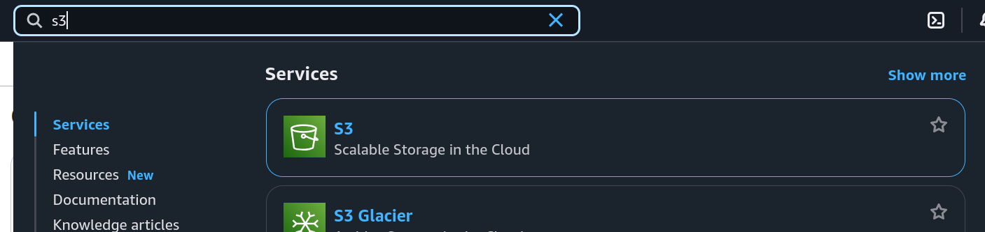

## Create bucket

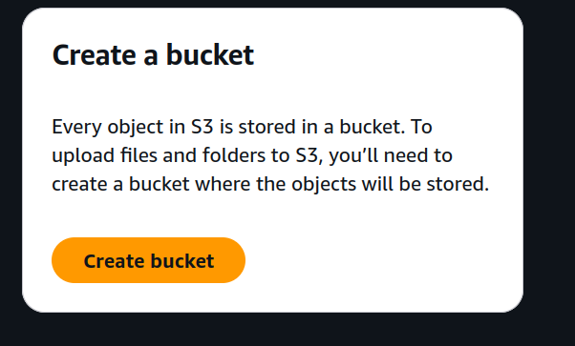

## Name bucket, and enable public access. Name must be unique across all users

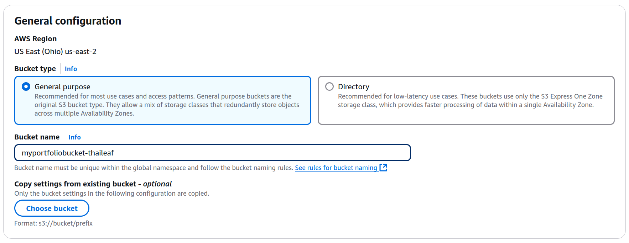

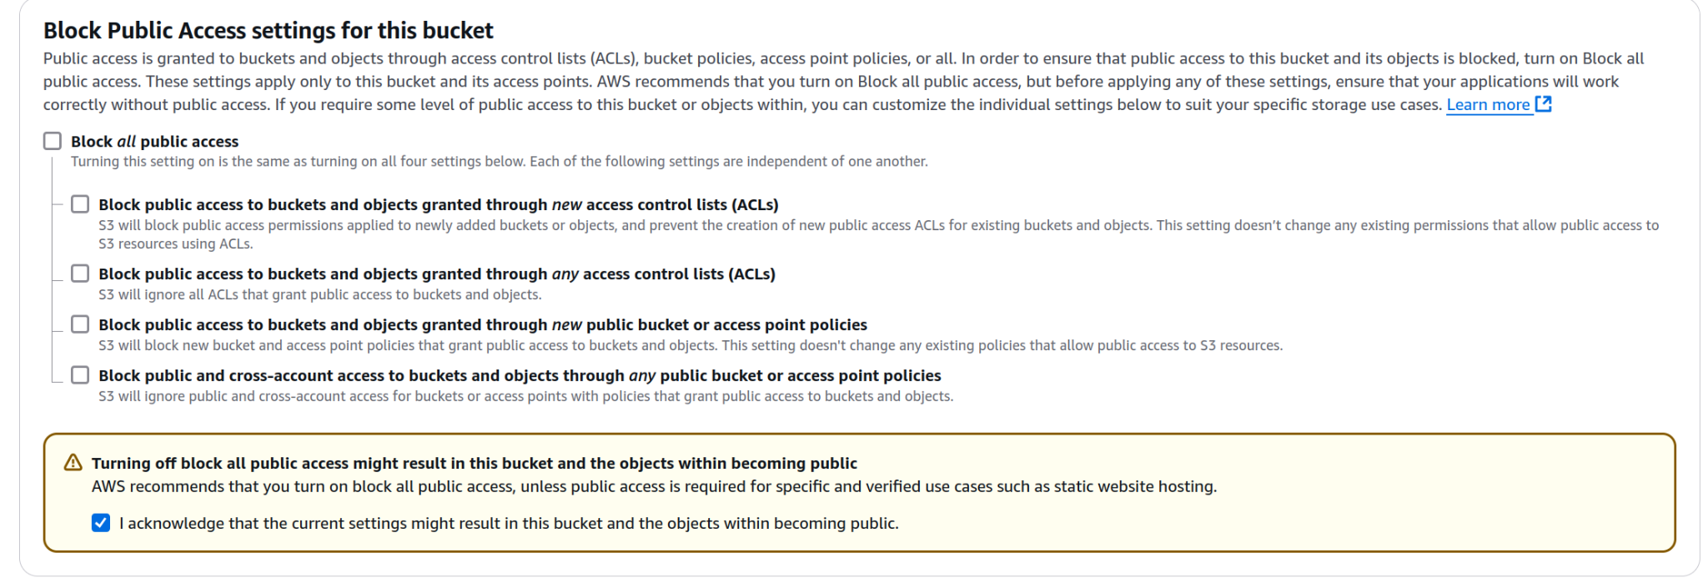

## Access bucket

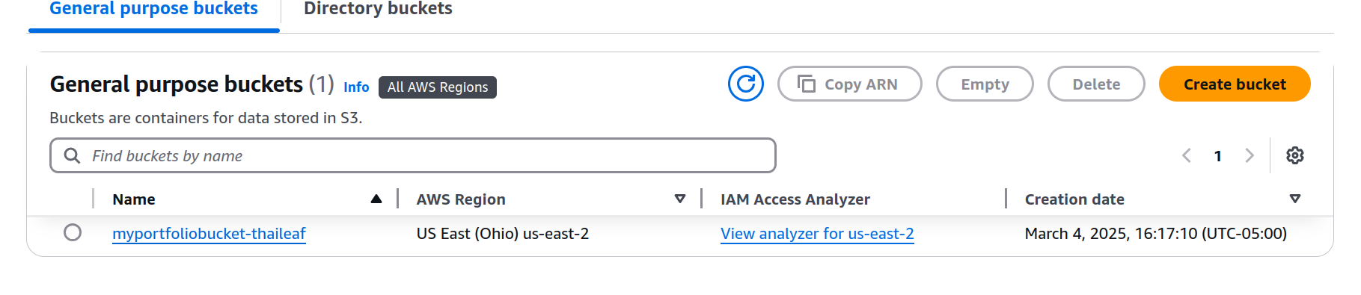

## Upload files. Then upload portfolio folder

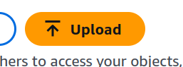

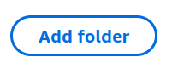



Then press upload button.

Should see this on completion  
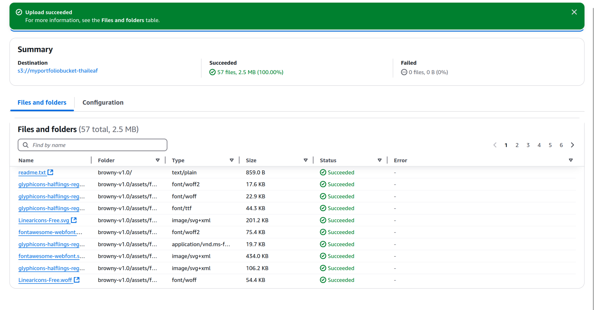

## Go back to bucket/ **open the properties Tab**

click on the destination link to go back

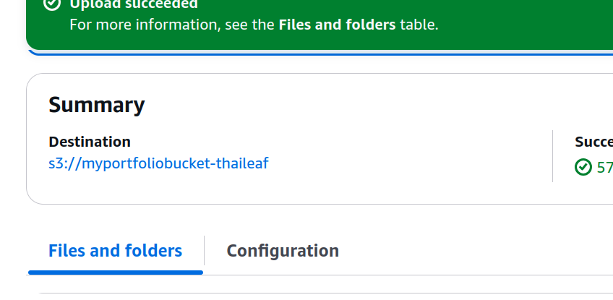

## Try accessing website

Find your index.html and click on copy url, then paste it in a different tab. What happens? You should see its forbidden. This is because even though we disabled block public access, we didn’t **enable** public access with an access policy. We will do that later.

Now press the Open button. What do you see now? You see we can access the index.html fine, but there’s no graphics. This is because you are only accessing the html, not the other css for designs. We will fix this by enabling static website hosting to allow the index.html to access the other files.

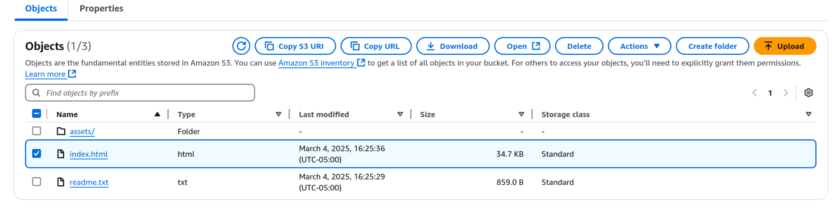

## Move files to top layer

Move all files to the top layer of the bucket. This is because index.html needs to be at the top layer

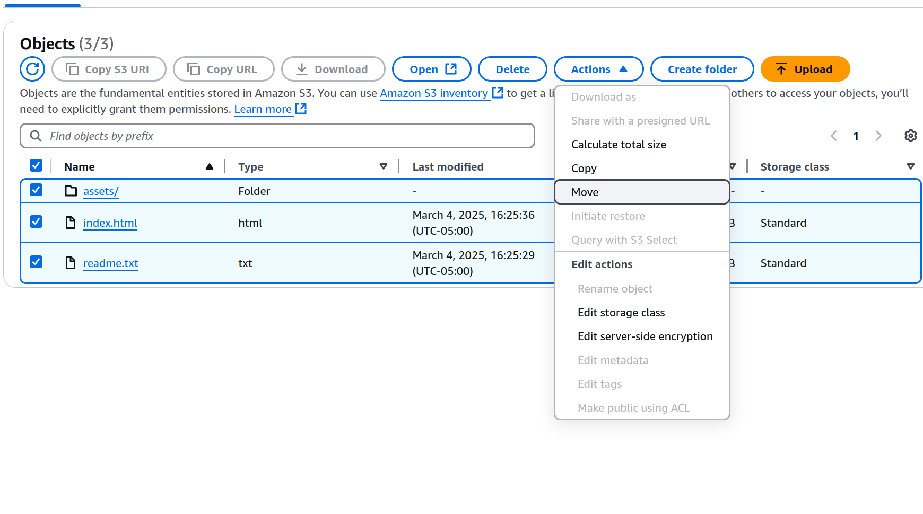

Click on the browse S3 to pick which bucket

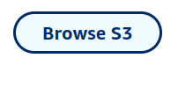

Click on your bucket and then press choose destination

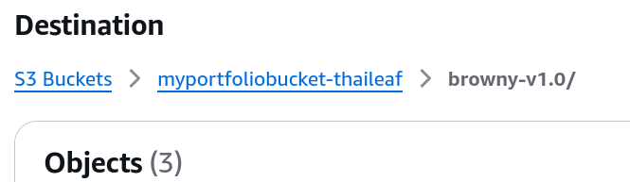

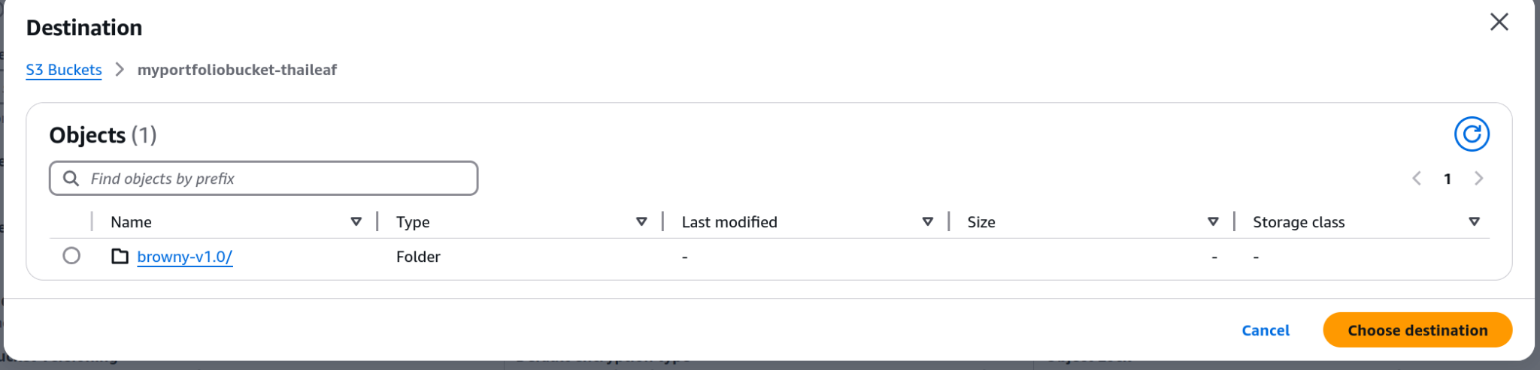

You should see this now in your destination

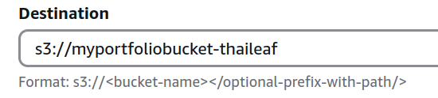

## Set up Static Website Properties

Go to properties tab

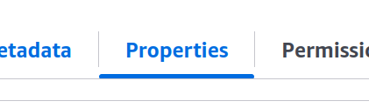

Scroll down and click on Edit on static website hosting

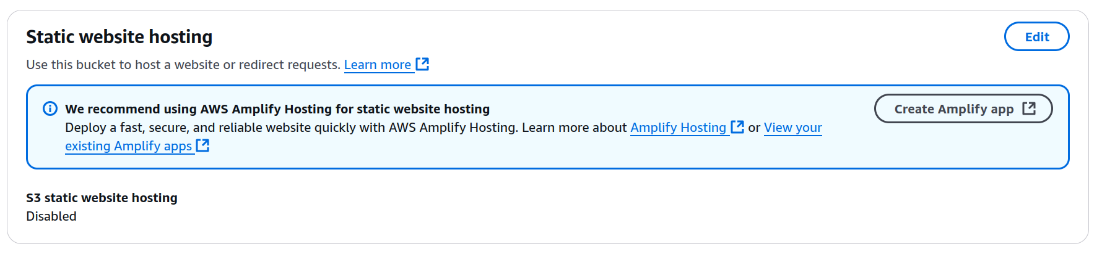

Enable static website hosting, then put index.html for the index document.

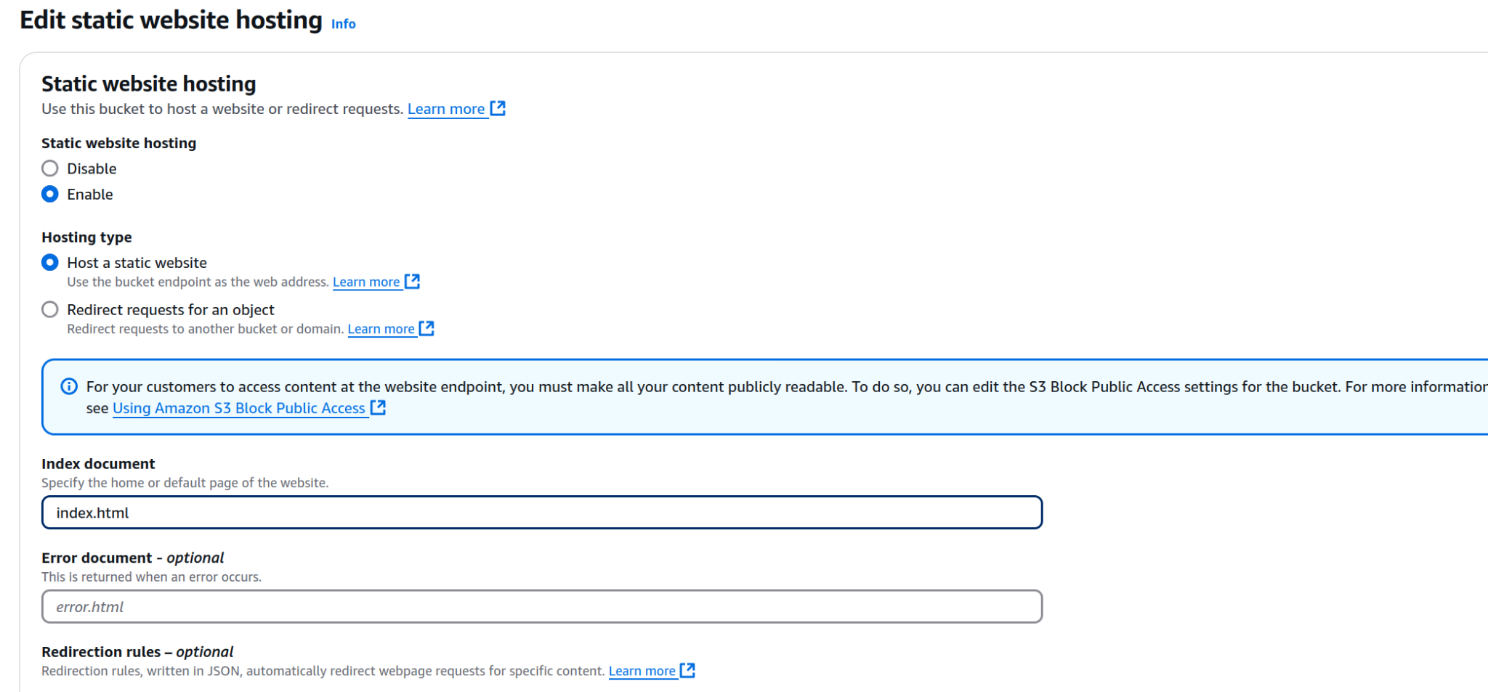

Try going to your endpoint url. What do you see? Still forbidden

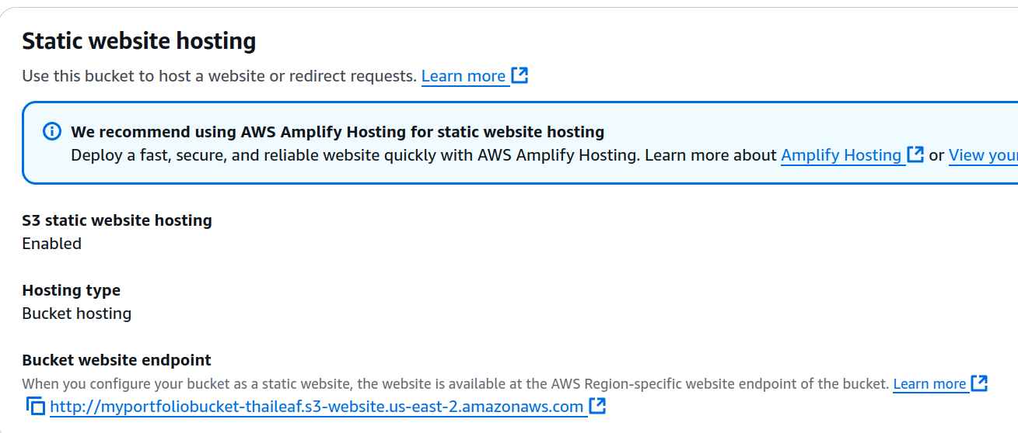

## Set up bucket policies

Go to permissions

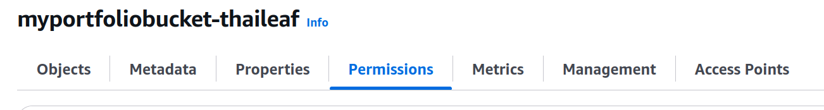

Edit bucket policies

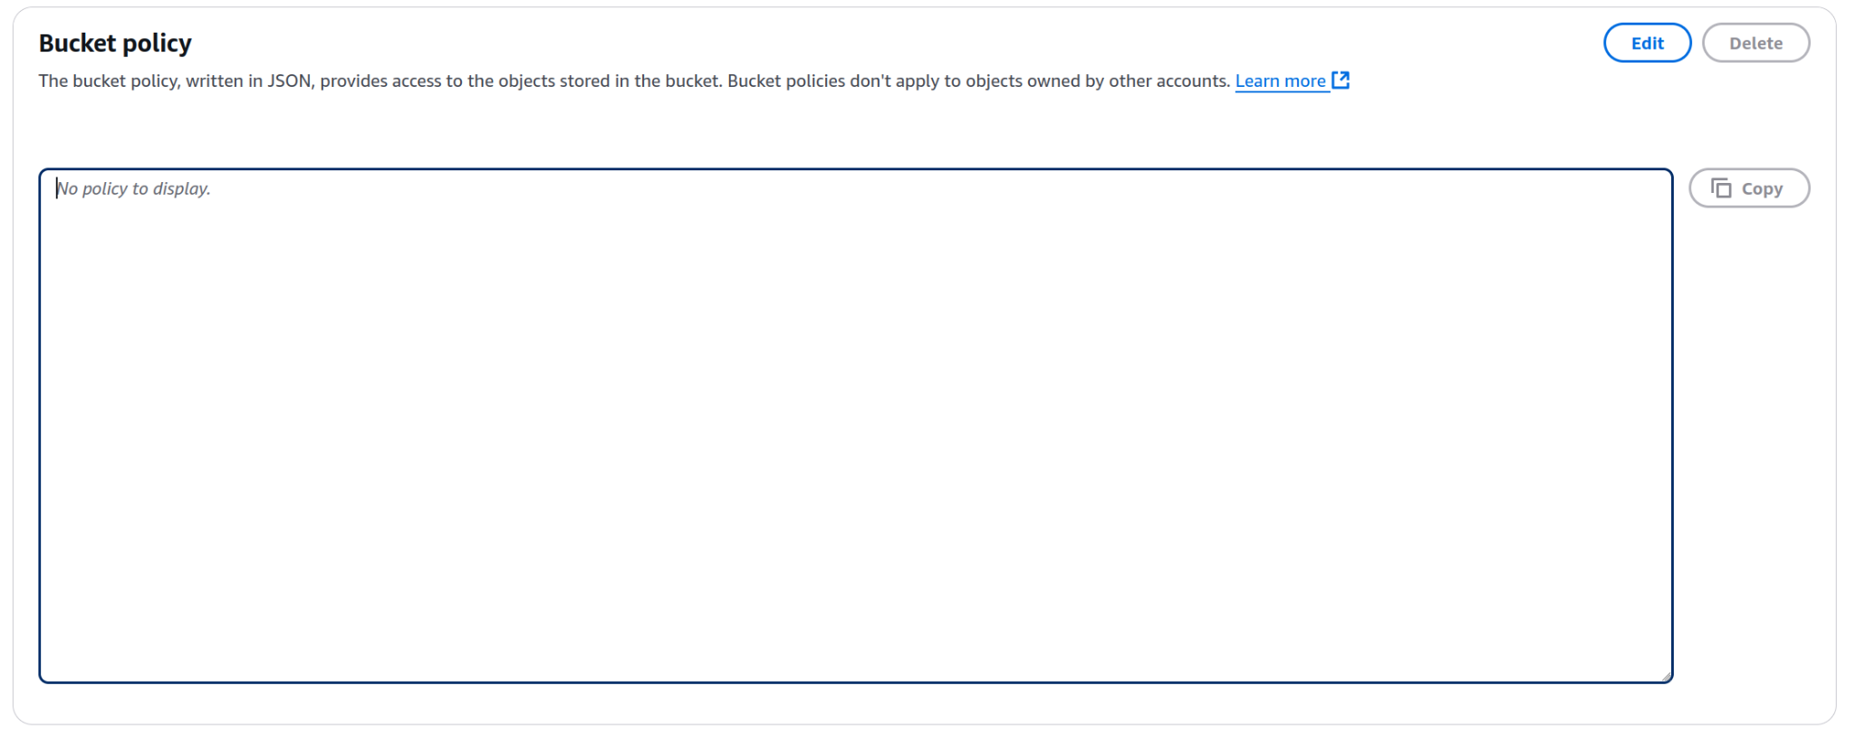

Copy paste this into bucket policy. Make sure you change bucket name to your bucket name.

{

"Version": "2012-10-17",

"Statement": [

{

"Sid": "PublicReadGetObject",

"Effect": "Allow",

"Principal": "*",

"Action": [

"s3:GetObject"

],

"Resource": [

"arn:aws:s3:::Bucket-Name/*"

]

}

]

}

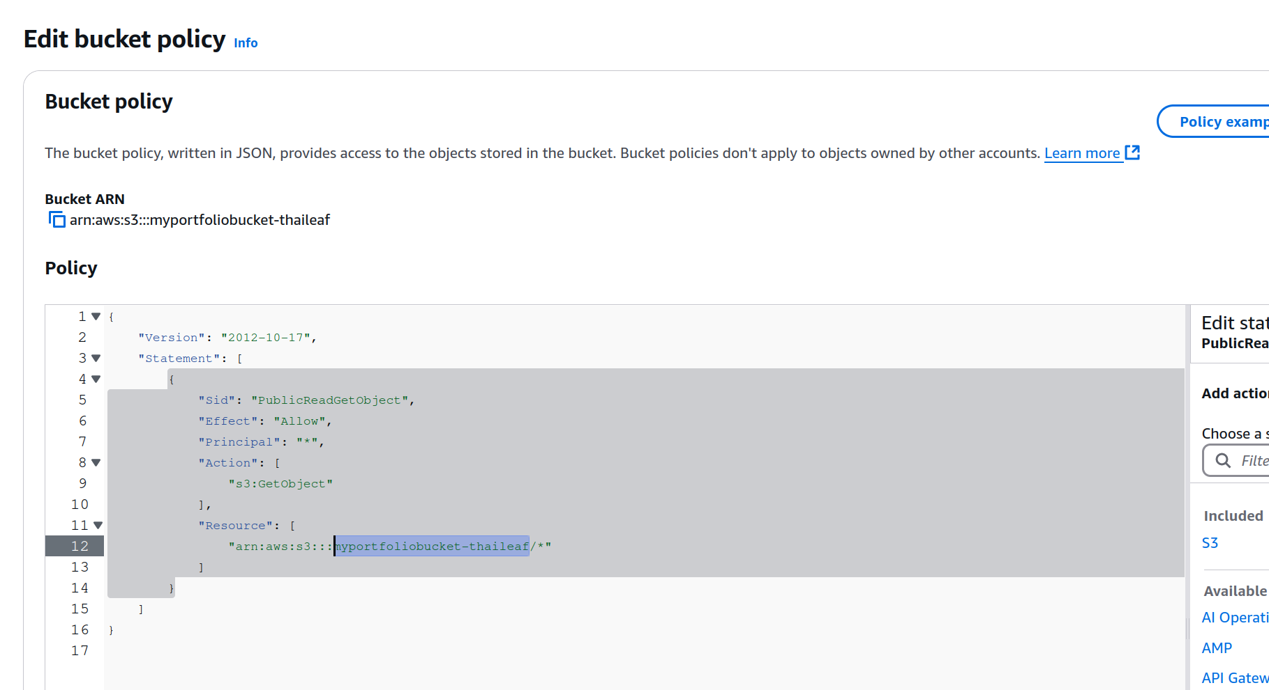

Now try the endpoint again.

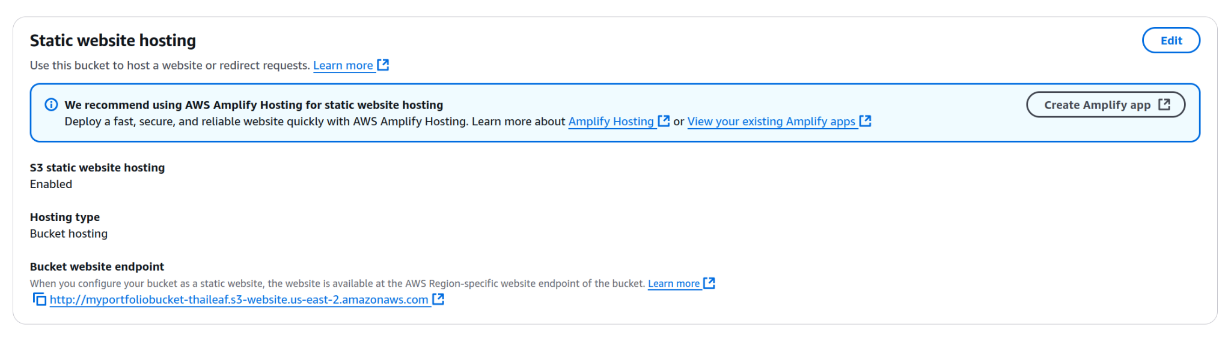

Congratulations! You’ve set up a static website on AWS